Progression Document.

These three areas should underpin the breadth of coverage of RE in our schools:

**SMSC Personal Growth and Development Community Cohesion**

In addition to these five threshold concepts

| **Understand beliefs and teachings** This concept involves understanding the key teachings of various religions. | **Understand practices and lifestyles** This concept involves understanding the day to day lives and practices of various religions. | **Understand how beliefs are conveyed** This concept involves understanding how books, scriptures, readings and other important means of communication are used to convey beliefs. |
| --- | --- | --- |
| **Reflect** This concept involves an appreciation of how religion plays an important role in | **Understand values** This concept involves an appreciation of how many people place values as an important aspect of their lives. |  |

To support the learning of RE, see how the Jigsaw units also cover the specific aspects of the strands.

RE coverage should aim to: provoke challenging questions; encourage pupils to explore their own beliefs; enable pupils to build their sense of identity and belonging; teach pupils to develop respect for others; prompt pupils to consider their responsibilities.

Children begin to recall and name different beliefs and main festivals associated with religions. Children can recognise different religious symbols, their relevance for individuals and how they feature in festivals.

**Milestone 1**

**Understand beliefs and teachings –** Children begin to recall and name different beliefs and main festivals associated with religions. Children can recognise different religious symbols, their relevance for individuals and how they feature in festivals.

**Children Can:**

**a**• Describe some of the teachings of a religion.

**b**• Describe some of the main festivals or celebrations of a religion.

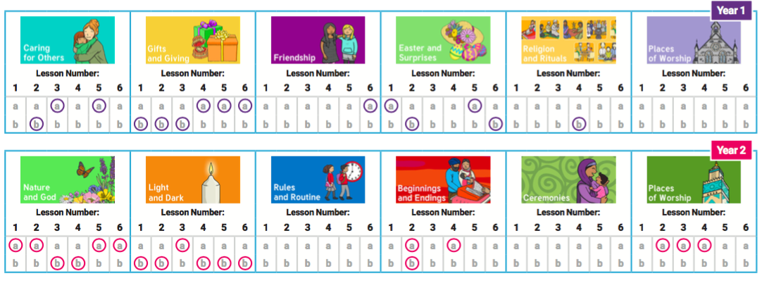

**Milestone 1**

**Understand values -** Children look at and appreciate how many people’s values are an important aspect of their lives. Children look at religious stories to understand actions and consequences. Children begin to make connections to their own lives, looking at their own actions and consequences and choices they can make

**Children Can:**

* **a**identify how they have to make their own choices in life
* **b**explain how actions can affect other people;
* **c**understand that they have their own choices to make and begin to understand the concept of morals.

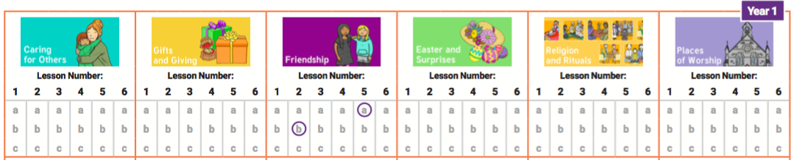

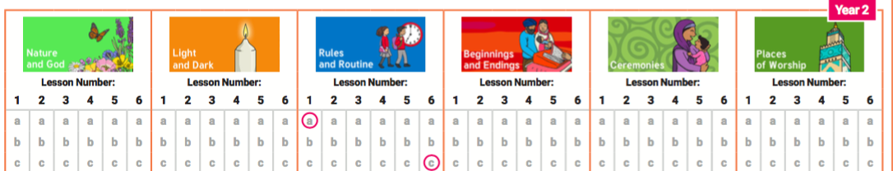

**Milestone 1**

**Understand practices and lifestyles** Children begin to explore daily practices and rituals of religions, identifying religious practices and recognising that some are featured in more than one religion. Children begin to reflect on their own experiences of attending ceremonies.

**Children Can:**

* **a**recognise, name and describe religious artifacts, places and practices;
* **b**explain religious rituals and ceremonies and the meaning of them, including their own experiences of them;
* **c**observe when practices and rituals are featured in more than one religion or lifestyle.  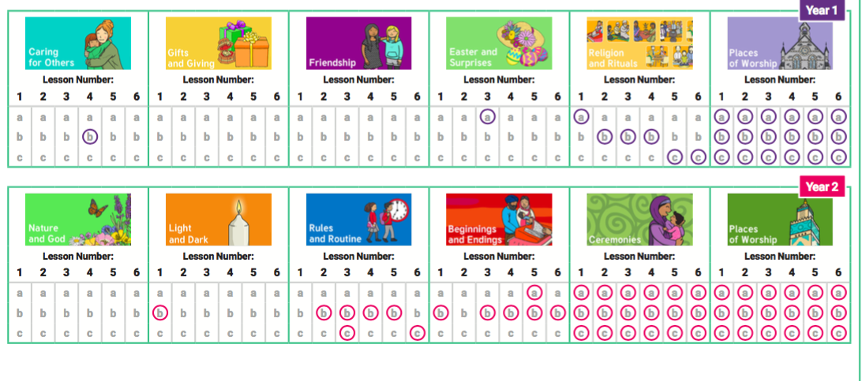

**Milestone 1**

**Reflect -** Children look at how an appreciation of religion plays an important role in the lives of some people. They make links to expressing identity and belonging and what is important to them.

**Children Can:**

1. identify things that are important in their lives;
2. ask questions about the puzzling aspects of life;
3. understand that there are similarities and differences between people.

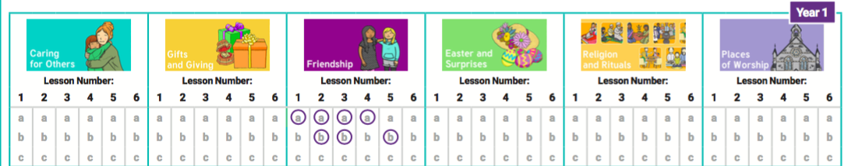

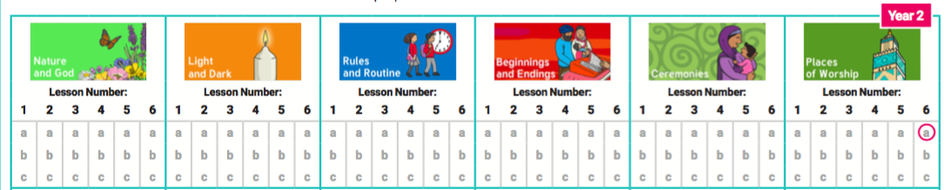

**Milestone 1**

**Understand how beliefs are conveyed -** Children begin to explore daily practices and rituals of religions, identifying religious practices and recognising that some are featured in more than one religion. Children begin to reflect on their own experiences of attending ceremonies.

**Children Can:**

* **a**recognise, name and describe religious artefacts, places and practices;
* **b**explain religious rituals and ceremonies and the meaning of them, including their own experiences of them;
* **c**observe when practices and rituals are featured in more than one religion or lifestyle.  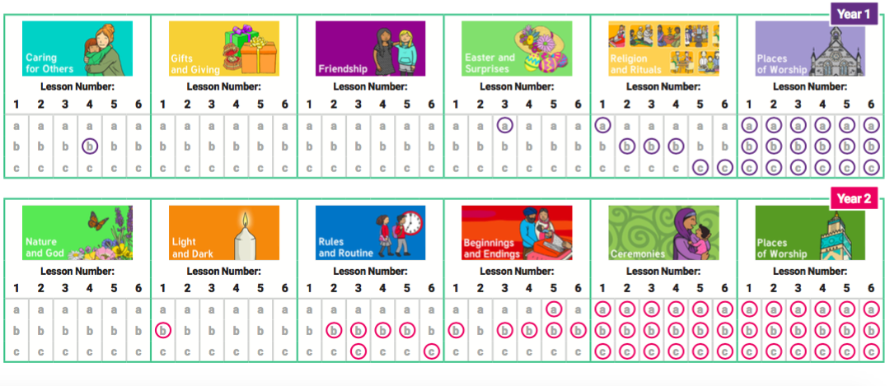

**Milestone 2**

**Understand beliefs and teachings –** Children can describe the key beliefs and teachings of the religions studied, making some comparisons between religions. Children expand on their knowledge of world religions from KS1.

**Children Can:**

* **a**describe the key teachings and beliefs of a religion;
* **b**begin to compare the main festivals of world religions;
* **c**refer to religious figures and holy books

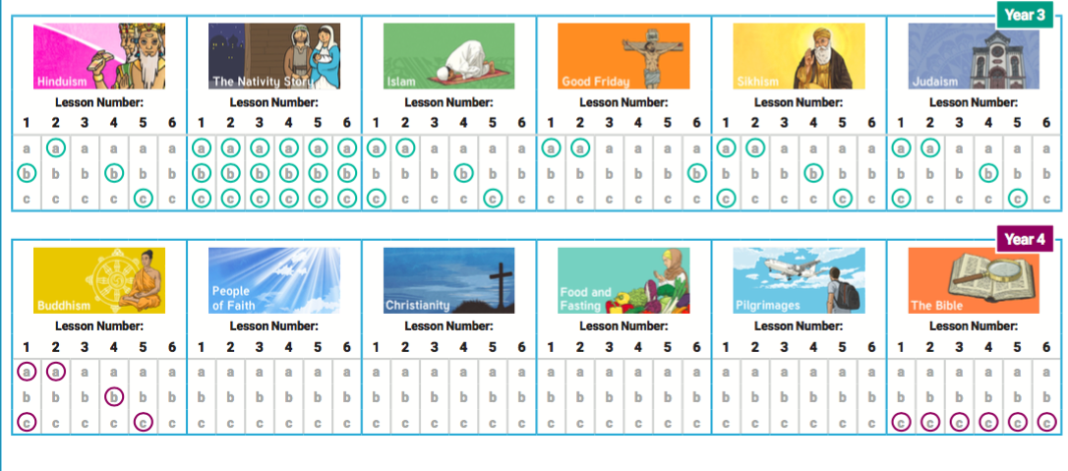

**Milestone 2**

**Reflect -**Children further explore how an appreciation of religion plays an important role in the lives of some people. They make links to expressing identity and belonging, including links to communities they may belong to. They notice and respond sensitively to different views.

**Children Can:**

* **a**understand that personal experiences and feelings can influence their attitudes and actions;
* **b**offer suggestions about why religious and non-religious leaders and followers have acted the way they have;
* **c**ask questions that have no agreed answers, and offer suggestions as answers to those questions;
* **d**understand that there are similarities and differences between people and respect those differences.  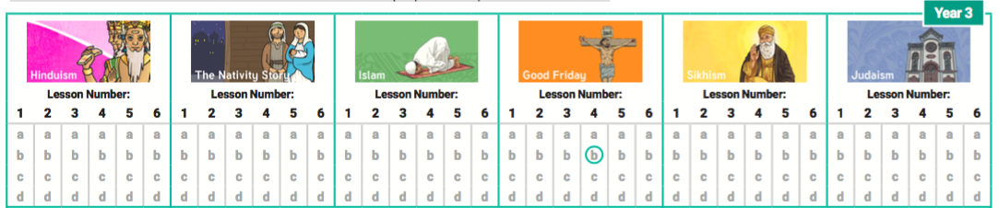

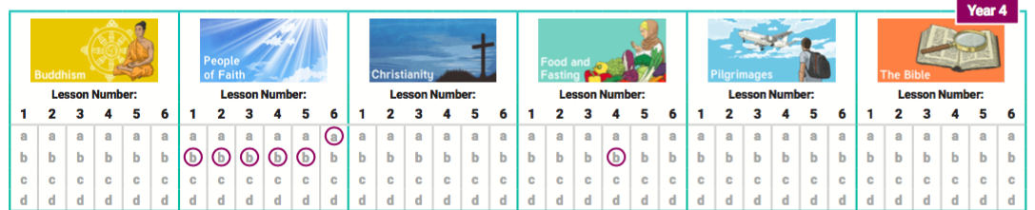

**Milestone 2**

**Understand how beliefs are conveyed -** Children explore the expression of beliefs through books, scriptures, art and other important means of communication. Children then move on to exploring a range of beliefs, symbols and actions to express meaning. Children can explain the meaning of religious stories and sources of wisdom and the traditions from which they come.

**Children Can:**

1. begin to identify religious symbolism in different forms of art and communication;
2. looking at holy texts and stories, explaining meaning in a story;
3. express their beliefs in different forms, with respect for others’ beliefs and comparing beliefs.

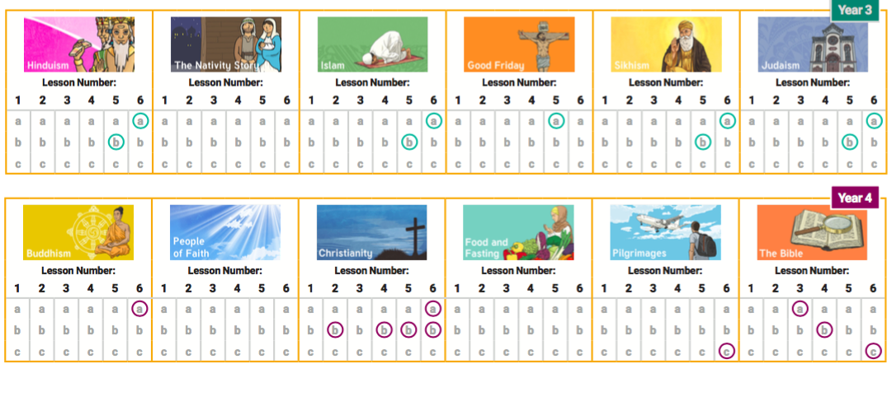

**Milestone 2**

**Understand values -** Children develop their appreciation of the ways in which people’s values are an important aspect of their lives. They make links to responsibility and citizenship and choices they make affecting their lives. Children begin to understand the concept of shared values and how a community can use shared values.

**Children Can:**

* **a**explain how beliefs about right or wring affect peoples behaviour;
* **b**describe how shared values in a community can affect behaviour and outcomes;
* **c**discuss and give opinions on morals and values, including their own.

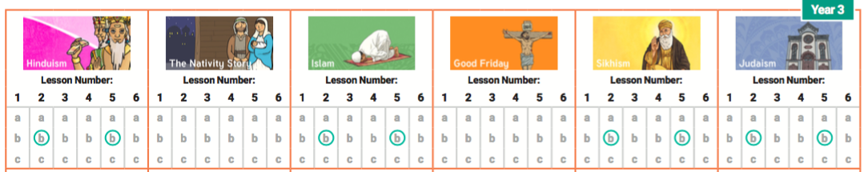

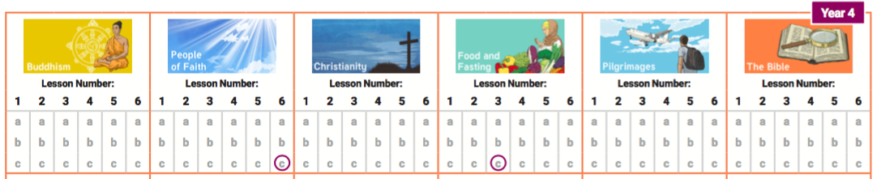

**Milestone 2**

**Understand practices and lifestyles** Moving on from KS1, children look at the concepts of belonging, identity and meaning. Children understand what belonging to a religion might look like, through practices and rituals, and what it might involve. Children begin to discuss and present thoughtfully their own and others’ views. Children also explore pilgrimages as a part of a religious life.

**Children Can:**

1. identify religious artifacts and how they are involved in daily practices and rituals;
2. describe religious buildings and how they are used;
3. explain religious ceremonies and rituals and their importance for people’s lives and sense of belonging.

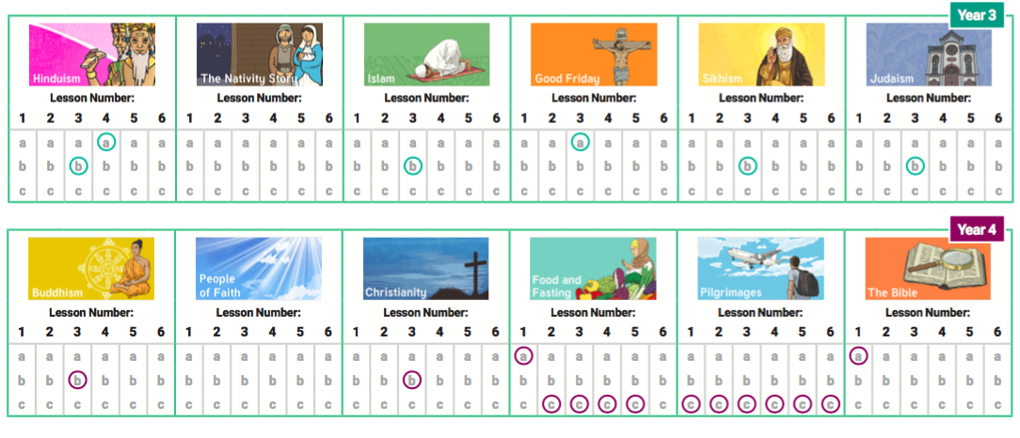

**Milestone 3**

**Understand beliefs and teachings –** Children can explain how beliefs and teachings can make contributions to the lives of individuals and communities. Children can compare the key beliefs and teachings of various religions, using appropriate language and vocabulary and demonstrating respect and tolerance.

**Children Can:**

**a**recognise and explain how some teachings and beliefs are shared between religions;

**b**explain how religious beliefs can shape the lives of individuals and contribute to society.

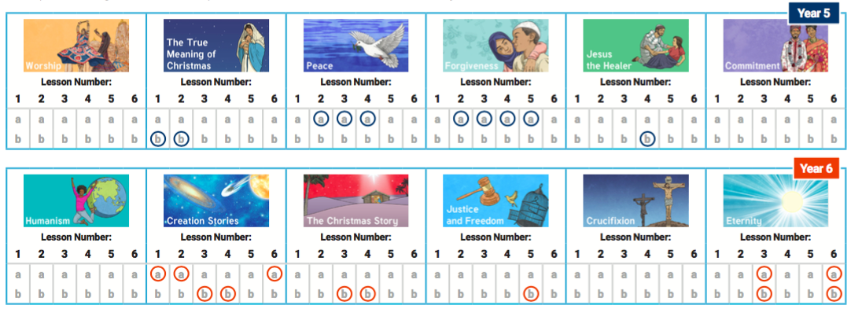

**Milestone 3**

**Reflect -** Children continue to develop their understanding how an appreciation of religion plays an important role in the lives of some people. They make links to expressing identity and belonging, and notice and respond sensitively to different views. Children can then discuss and apply their own and others’ ideas about ethical questions, including ideas about what is right and wrong and what is just and fair.

**Children Can:**

* **a**recognise and express feelings about their identities and beliefs;
* **b**explain their own opinions about tricky concepts and tricky questions that have no universally agreed answers;
* **c**explain why their answers may be different from someone else’s and respond sensitively.  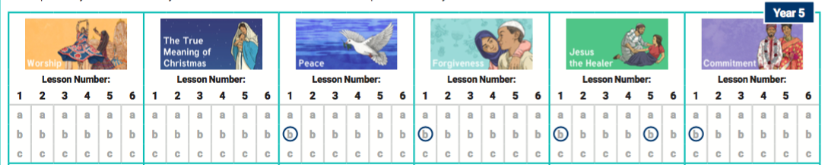

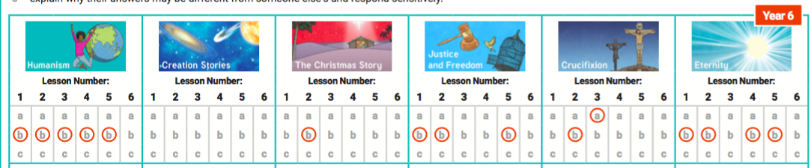

**Milestone 3**

**Understand how beliefs are conveyed -** Children continue to explore the expression of beliefs through books, scriptures, art and any other important means of communication, as in LKS2. Children then move on to exploring a range of beliefs, symbols and actions so they can understand different ways of life and expressing meaning. Children can explain meaning of religious stories, sources of wisdom and the traditions from which they come.

**Children Can:**

1. explore religious symbolism in literature and the arts;
2. explain some of the different ways individuals show their beliefs;
3. share their opinion or express their own belief with respect and tolerance for others.  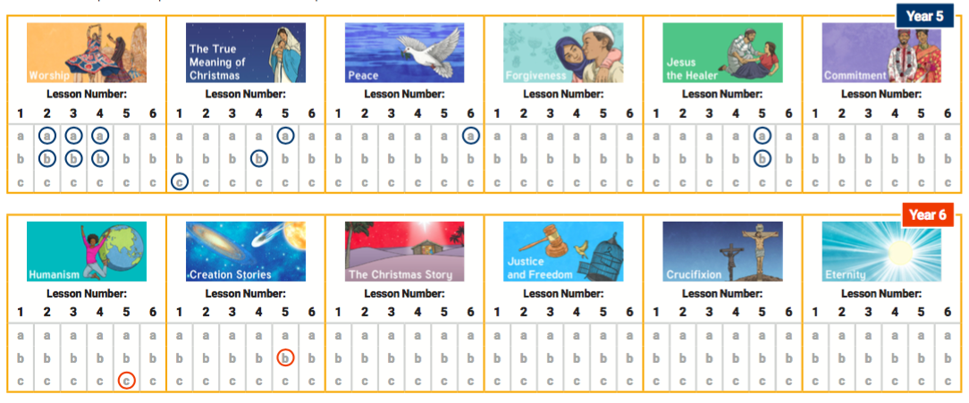

**Milestone 3**

**Understand values -** Children continue to develop their appreciation of the ways in which people’s values are an important aspect of their lives. They make links to responsibility and citizenship. Children begin to understand the concept of shared values and how a community can use shared values. Moving on from their previous learning, children begin to strengthen their capacity for moral judgements.

**Children Can:**

* **a**explain why individuals and communities may have similar and differing values;
* **b**show an awareness of morals, question morals and demonstrate an ability to make choices, understanding the consequences;
* **c**express their own values while respecting the values of others.  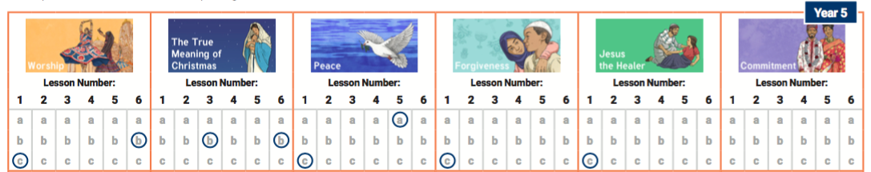

**Milestone 3**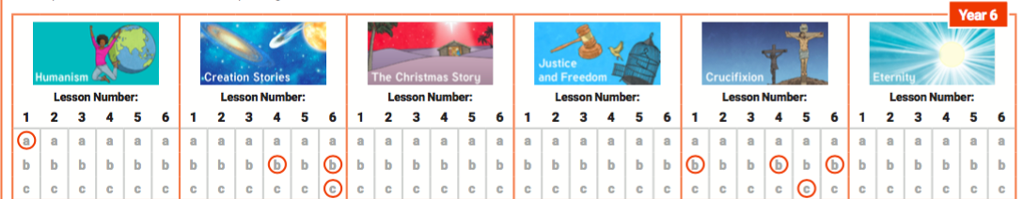

**Understand practices and lifestyles** Children look further at the concepts of belonging, identity and meaning. They understand how certain features of religion make a difference to individuals and communities. Children also explore the rituals and ceremonies which mark important points in life. Moving on from LKS2, children will have the opportunity to explore non-religious ways of life.

**Children Can:**

1. explain practices and lifestyles associated with belonging to a faith;
2. explain practices and lifestyles associated with belonging to a non-religious community;
3. compare lifestyles of different faiths and give reasons why some people within the same faith choose to adopt different lifestyles;
4. show an understanding of the role of a spiritual leader.  